Customer Shopping Behavior Analysis

Project Overview
This project analyzes customer shopping behavior using transactional data from 3,900 purchases across various product categories. The goal is to uncover insights into spending patterns, customer segments, product preferences, and subscription behavior to guide strategic business decisions.

Dataset Summary
- Rows: 3,900
- Columns: 18
- Key Features:
- Customer demographics (Age, Gender, Location, Subscription Status)
- Purchase details (Item Purchased, Category, Purchase Amount, Season, Size, Color)
- Shopping behavior (Discount Applied, Promo Code Used, Previous Purchases, Frequency of
Purchases, Review Rating, Shipping Type)
- Missing Data: 4 values in Review Rating column

Exploratory Data Analysis using Python
We began with data preparation and cleaning in Python:
- Data Loading: Imported the dataset using pandas.

- Initial Exploration: Used df.info() to check structure and .describe() for summary statistics.
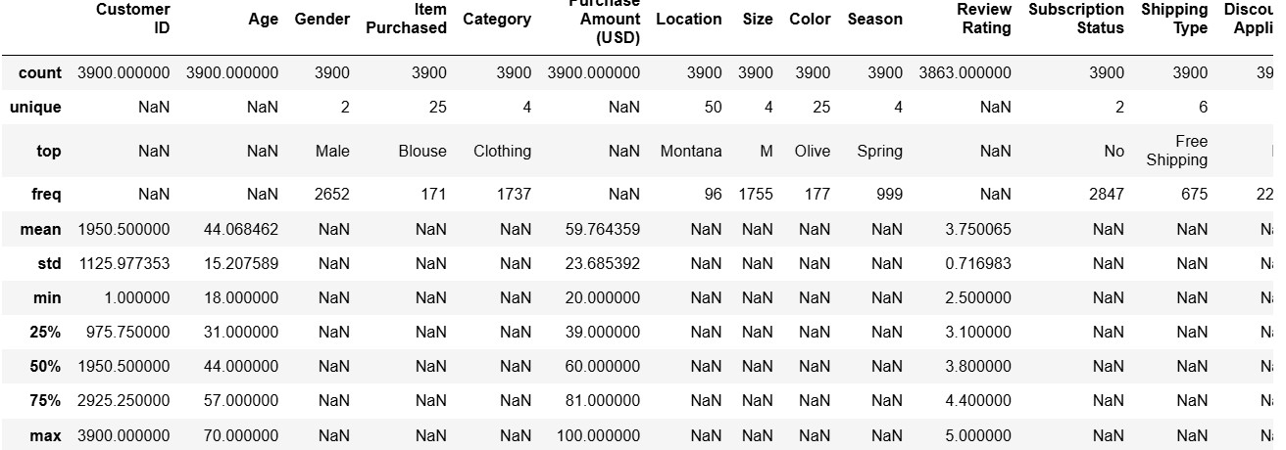
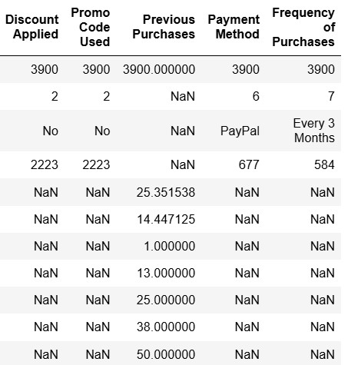
- Missing Data Handling: Checked for null values and imputed missing values in the Review Rating column using the median rating of each product category.

- Column Standardization: Renamed columns to snake case for better readability and documentation.

- Feature Engineering:

○ Created age_group column by binning customer ages.

○ Created purchase_frequency_days column from purchase data.

- Data Consistency Check: Verified if discount_applied and promo_code_used were redundant; dropped promo_code_used.

- Database Integration: Connected Python script to PostgreSQL and loaded the cleaned DataFrame into the database for SQL analysis.

Data Analysis using SQL (Business Transactions)
We performed structured analysis in PostgreSQL to answer key business questions:
- Revenue by Gender – Compared total revenue generated by male vs. female customers.
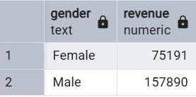

- High-Spending Discount Users – Identified customers who used discounts but still spent above the average purchase amount.
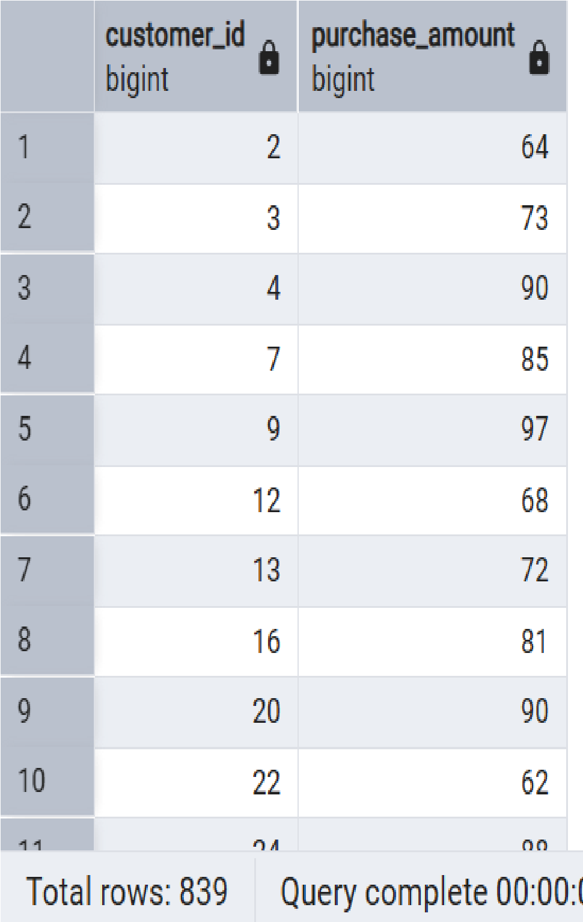

- Top 5 Products by Rating – Found products with the highest average review ratings.

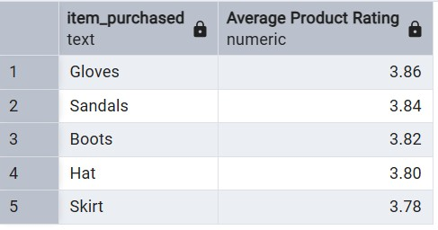
- Shipping Type Comparison – Compared average purchase amounts between Standard and Express shipping.
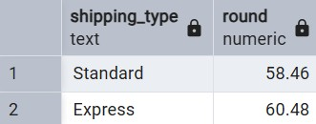

- Subscribers vs. Non-Subscribers – Compared average spend and total revenue across subscription status.
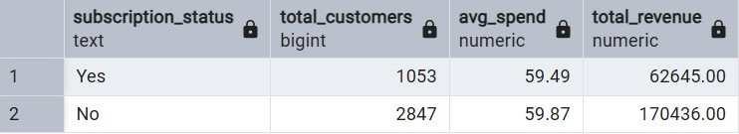

- Discount-Dependent Products – Identified 5 products with the highest percentage of discounted purchases.
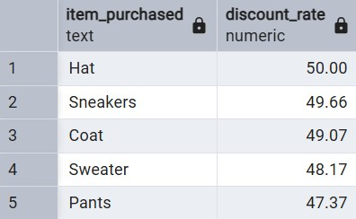

- Customer Segmentation – Classified customers into New, Returning, and Loyal segments based on purchase history.
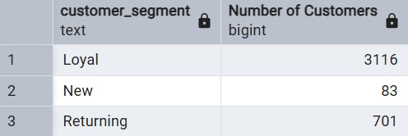
- Top 3 Products per Category – Listed the most purchased products within each category.
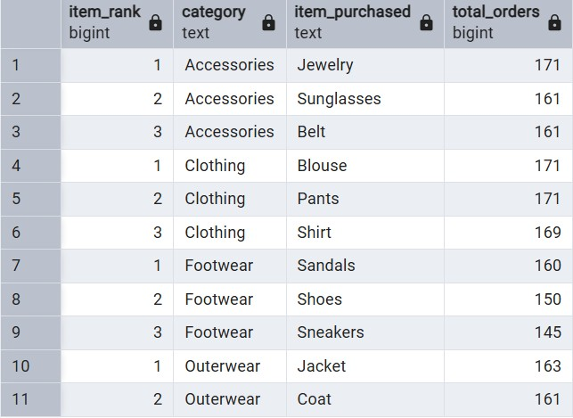
- Repeat Buyers & Subscriptions – Checked whether customers with >5 purchases are more likely to subscribe.
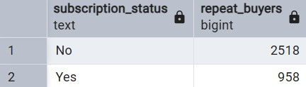
- Revenue by Age Group – Calculated total revenue contribution of each age group.
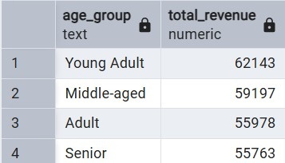

Dashboard in Power BI

Finally, we built an interactive dashboard in Power BI to present insights visually.

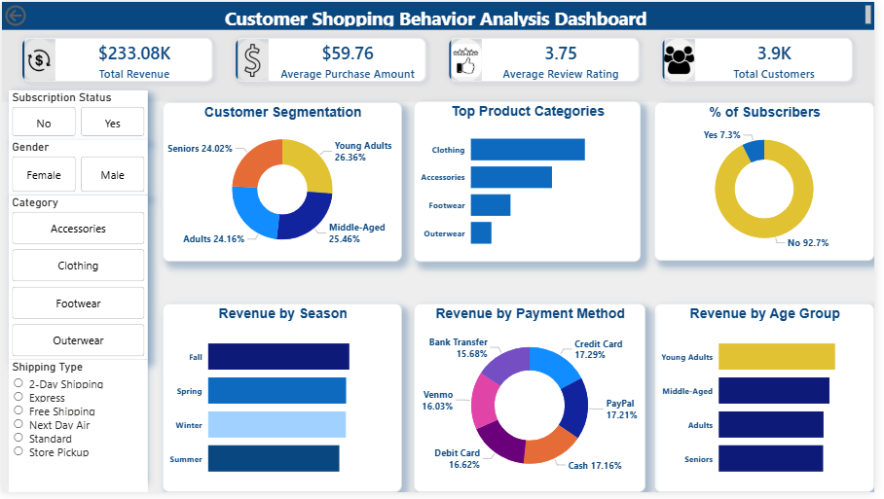

Key Insights

1. Young Adults Generate the Highest Revenue
The Young Adult segment contributes the largest share of revenue, indicating that this age group has the strongest purchasing behavior among all customer segments.

2. Clothing and Accessories Are the Leading Product Categories
Among all categories, Clothing generates the highest sales, followed by Accessories, showing strong customer demand for fashion-related products.

3. Subscriber Adoption Is Very Low
Only 7.3% of customers are subscribers, while 92.7% are non-subscribers, suggesting a significant opportunity to grow customer retention through subscription programs.

4. Revenue Is Fairly Distributed Across Payment Methods
Customers use a mix of Credit Card, PayPal, Cash, Debit Card, Bank Transfer, and Venmo, indicating that offering multiple payment options supports customer convenience.

5. Seasonal Demand Influences Sales Performance
Sales vary across seasons, with Fall and Spring showing relatively stronger revenue, suggesting that customer purchasing behavior is influenced by seasonal demand.

Business Recommendations

1. Expand Subscription Programs
Introduce exclusive benefits such as member-only discounts, early product access, and free shipping to increase subscription adoption and improve customer retention.

2. Target High-Value Customer Segments
Focus marketing campaigns on Young Adults, as they generate the highest revenue and present strong growth potential.

3. Prioritize High-Performing Product Categories
Promote Clothing and Accessories through featured campaigns, homepage placement, and promotional bundles to maximize revenue from top-selling categories.

4. Implement Seasonal Marketing Strategies
Align marketing campaigns and promotions with high-performing seasons to capitalize on increased customer demand.

5. Encourage Higher Purchase Value
Introduce incentives such as bundle offers, loyalty rewards, or free shipping thresholds to increase the average purchase amount per transaction.

